JOIN US FOR 2026 EXCITING MISSION TRIP TO MALAWI
The Presbytery of WNC has a 21-year partnership with Nkhoma Synod in Malawi. Come and see. Come and experience God at work as we continue growing our relationships and partnership with our Malawian brothers and sisters. Come and experience this part of Africa and work together in mission as God keeps expanding our ministry there.
- Worship with fellow Christians, experiencing incredible joy and music.
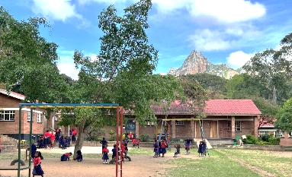
- Visit with the children at Ebenezer School, a school that PWNC helped develop and continues to support. Experience their morning assembly, tour the school and classrooms, and talk with the children and teachers about their hopes and dreams.
- Visit 280-bed Nkhoma Hospital complex, a referral center for healthcare for about 500,000 people, which we have supported since 2004. Worship with the hospital staff Wednesday morning.
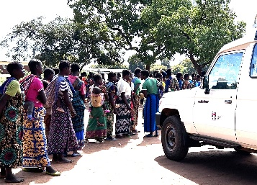
- Journey to remote areas with a mobile health unit to experience healthcare ministry to women and children, many who walked more than an hour to visit the mobile clinic.
- Meet the head Chaplain, learning about local chaplaincy work.
- Visit the University’s first women’s dorm that we helped build.
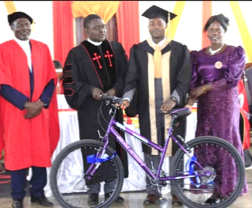
- Share meals and tea with Malawian friends, building friendships, learning about their lives, sharing stories of challenges and joys.
- Meet the current seminarians, whom we support. Visit a classroom, and celebrate with the graduates. PWNC provides Study Bibles to all the students, and clerical shirts and bikes to the graduates.
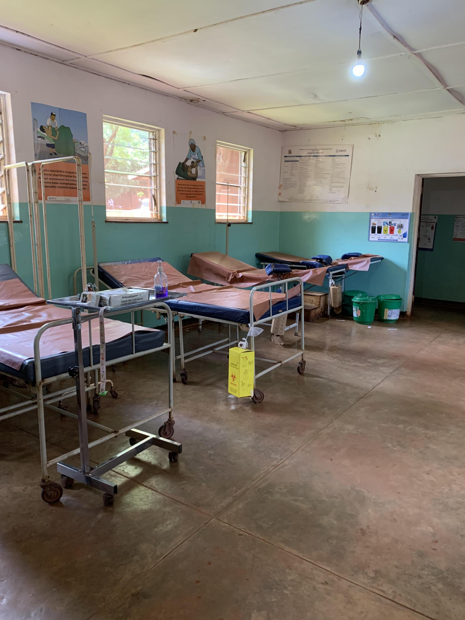
- Learn about “Men in the Mirror,” a study for men that uses Jesus as the model for faith and relationships with others, particularly women and children. Hear from pastors how it has made a difference in their lives and their churches. This is a study designed by Kevin Frederick, a pastor in our Presbytery.
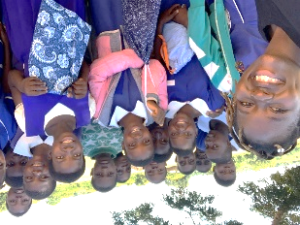
- Visit local schools to present washable, reusable hygiene pads to girls and teachers, and teach them about their use. Understand the impact that this has to keep girls in school and support women. The hygiene products are made by PWNC churches.
- Visit one of the eleven health centers to learn about the needs and to witness how they serve their communities. At Malingunde, see what it means to have upgraded water and sanitation systems, which provide potable water for patients and staff. This was a critical project of PWNC in 2024.
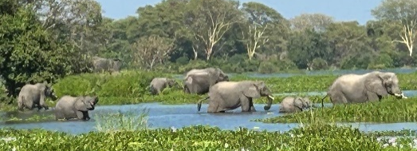
- Visit a game park overnight and go on Safari.
- Enjoy new friendships with the mission team and Malawians, surprises of good news. Deepen your faith as we explore together what it means to be one in faith, mission and service.

PWNC DELEGATION TO MALAWI
APPLICATION FOR THE APRIL TRIP
We are excited that you are considering going on the 2026 Malawi Mission Trip. It is a life changing experience with our brothers and sisters in Christ. It is also a fun time; seeing new things, making new friends, and experiencing how God is at work in Malawi and in our lives.
Please free to call us to get more information or answer your questions.
CURRENT PLANS AND DATES:
Plans are in process. If you are considering going it is important to get started now with an application, as well as addressing passport and all medical and vaccination needs.
- Our plan is for the team to depart from Charlotte on Friday, 4/17 AM, arriving in Malawi on Saturday, 4/18, afternoon. Return trip will depart from Malawi on Friday 5/1, arriving in Charlotte on Saturday, 5/2 afternoon. The trip involves 16 days, with 4 of those as travel days (2 days each way). That gives us 12 complete days in Malawi. Please let us know if you have questions about the dates.
- If you are considering going, please contact us so we can answer any questions and talk with you about any specific interest you might have.
Bobbi White 828-674-5009 or bobbiwhite02@gmail.com
Terri Forsyth 980-229-9949 or forsythetcr@aol.com

For those planning to go, you will need to complete the application on the website or attached. Mail your application to: Presbytery of Western. WNC, 114 Silver Creek Road, Morganton, NC 28655 or email twilliams@presbyterywnc.org.
COST:
The cost for the trip is $3,400 which includes airfare, transportation in Malawi, lodging, food, and the game park. It does not cover personal preparation expenses (passport, immunizations, medicines, etc.). Be sure to get immunizations early. In Malawi, we will be staying in one of the local lodges. Breakfast and dinner will be prepared for us. Lunches will be arranged based on daily schedules.
Some scholarship/financial assistance is available. Often, your home congregation will help. Bobbi White will work with you on finances.
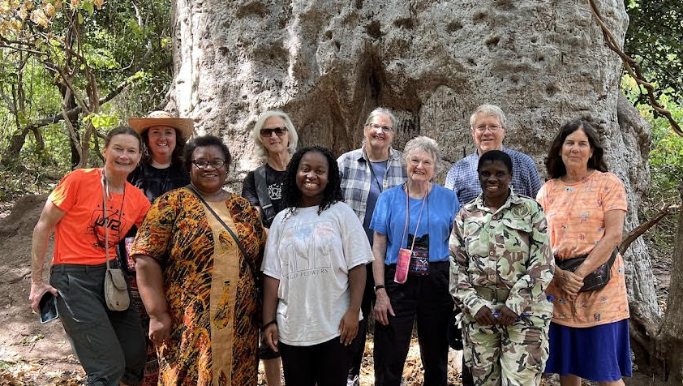
Please make checks payable to PWNC. Plane reservations will be made in January. Once plane reservations are booked in your name, it is considered a commitment to pay and participate in the trip. $2,000 is due at the end of January, with the second payment of $1,400 due March 1.

Preparation Before Departure:
Participants will receive an informational notebook, and two meetings will be held for orientation, planning, and team-building. These sessions will help you get acquainted with fellow travelers and prepare for the long journey and collaborative work in Malawi.

